**Assignment 02**

**Question 01:**

Write a C++ program that asks user to enter two numbers. Pass the numbers to a function check_prime() that displays all the prime numbers between these two numbers and returns the total count of prime numbers found.

**Sample Output:**

Enter first number: 6

Enter second number: 15

Prime numbers are: 7 11 13

Total Prime numbers: 3

**Question 02:**

Write a C++ program to evaluate the following expression:

$${3^{2}+a}^{2}+b+3ab$$

To evaluate the above expression, you can only use following functions and no other function should be created:

int calcMul(int,int);

int calcSum(int,int);

**Sample Output:**

Enter a: 10

Enter b: 2

Result is: 171

**Question 03:**

Write a C++ Program that reads data from a file data.txt. program should ask the user to enter the city and display the name in upper case and contact no. of the persons from that city. Make a function toUpper() to change the case of name. If there is no record from that city, display a message “no record found”.

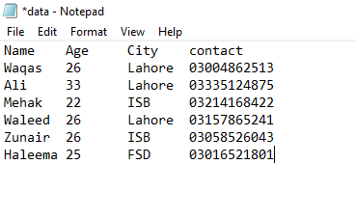

**Sample Output 1:**

Enter city: Lahore

WAQAS 03004862513

ALI 03335124875

WALEED 03157865241

**Sample output 2:**

**Enter City: BWP**

Output:

No record found